1) The Little Mermaid lives in an underwater kingdom. She lives in a castle in the center of the kingdom. The front of the castle is 45 feet high. Little Mermaid, standing 5 feet tall, is 9 feet away from the front of the castle. What is the shortest distance from the top of the front of the castle to the top of Little Mermaid’s head?

**A) 41 B) 49 C) $\sqrt{1519}$ D) E) NOTA**

2) The Sea King has a long flowing beard, with a density of 3 grams per cubic inch. Because he takes very good care of it, it is in the shape of a perfect cone. His beard weighs 54 $π$ grams, and has a radius of 3 inches. What is the height of his beard in inches?

**A) 2 B) 6 C) 9 D) 18 E) NOTA**

3) The Little Mermaid, born five years after her youngest sister, is a daughter of the Sea King. She has five sisters. Each of them were born one year apart. The sum of the ages of all daughters is 65 years. What is the age of the youngest daughter?

**A) 15 years B) 11 years C) 10 years D) 9 years E) NOTA**

4) The Little Mermaid’s voice was beautiful. When she sang, flocks of fish came from all over the sea to listen to her. Mesmerized by her voice, her biggest fan, Kewen the fish decided to gives her some pearls, in hopes of winning her love. In order to be successful, he needed to gift to her a total of 540 $π$ cubic centimeters worth of pearls. If each pearl is in the shape of a perfect sphere witha diameter of 6 centimeters, how many pearls did he need?

**A) 2 B) 15 C) 20 D) 60 E) NOTA**

5) When the Little Mermaid sings, the fishes dance. The paths of their dance are in the shape of four non-overlapping circles, each with radius 4 feet. Each circle is tangent to 2 other circles. The area bounded by the four circles can be written in the form a + b $π$, where a and b are in square feet. What is the value of a - 2b?

**A) 32 B) 64 C) 80 D) 96 E) NOTA**

6) One day, the Little mermaid rises to the surface of the water and sees a celebration on a ship. On the ship, the Little Mermaid sees a handsome young prince and falls in love. Suddenly, a storm strikes, and the ship hits a rock, creating multiple holes. The ocean begins to flood the ship at a rate of 4 $π$ cubic feet per 3 seconds. The ship is in the shape of a regular frustum with height of 8 feet and rectangular base with a length of 36 feet and a width of 18 feet. The smaller base has a length of 24 feet. 75% of this volume is empty. How long, in seconds, will it take for the ship to completely submerge? (Assume the ship submerges when one third of the ship’s empty volume is filled with water)

**A) 684 B) 836 C) 912 D) 1216 E) NOTA**

7) The locations of the prince, the Little Mermaid, and the ship form a right triangle on the water surface. The right triangle has a perimeter of 48 feet and a hypotenuse of 20 feet. What is its area, in square feet?

**A) 92 B) 96 C) 192 D) 200 E) NOTA**

8) Off in the distance, lightning strikes a tree on an island, snapping it and causing it to fall. The top of the tree lands on the island ground 15 feet away from the tree’s base. If the tree stood 75 feet tall before being struck by lightning, how high is it off the ground now? (The point where it was struck by lightning)

**A) 60 ft B) 39 ft C) 36 ft D) 30 ft E) NOTA**

9) Unfortunately, many died in the shipwreck. Holes were dug for them in the shape of rectangular prisms 8 feet long, 4 feet wide, and 3 feet deep. What is the surface area of these holes, in square inches?

**A) 136 B) 112 C) 104 D) 68 E) NOTA**

10) What is the volume of each hole from question #9 in cubic inches?

**A) 96 B) 48 C) 32 D) 12 E) NOTA**

***Having fallen in love with the prince she rescued, the Little Mermaid longs for the prince and an eternal soul. She visits the Sea Witch for assistance, who arranges a deal with the Little Mermaid. First, the Little Mermaid must answer a series of geometry questions.***

11) What is the measure of an interior angle of a nonagon?

**A) 120° B) 140° C) 150° D) 162° E) NOTA**

12) How many vertices does a regular icosahedron have?

**A) 24 B) 20 C) 18 D) 12 E) NOTA**

13) Which of these points of concurrency is not contained by Euler’s Line?

**A) Centroid B) Orthocenter C) Circumcenter**

**D) Incenter E) NOTA**

14) What is the contrapositive of the inverse of this statement: “If you answer all these questions correctly, then you will have an eternal life.”

**A) “If you answer all these questions correctly, then you will have an eternal life.”**

**B) “If you don’t answer all these questions correctly, then you will not have an eternal life.”**

**C) “If you will have an eternal life, then you answer all these questions correctly.”**

**D) “If you won’t have an eternal life, then you don’t answer all these questions correctly.”**

**E) NOTA**

15) Two supplementary angles have measures of 6x and 12x - 18. What is the supplement of the complement of the smaller angle?

**A) 156 B) 114 C) 66 D) 24 E) NOTA**

16) In concave hexagon ABCDEF, m∠A = m∠B = m∠C = 90◦, m∠D = 100◦, and m∠F = 80◦. Additionally, CD = FA, AB = 7, BC = 10, and EF + DE = 12. Find the area of the hexagon.

**A) $\frac{69}{2}$ B) $\frac{135}{4}$ C) $\frac{71}{2}$ D) E) NOTA**

17) Find the volume in cubic inches of the solid formed when rotating an equilateral triangle with side length 6 about one of its sides?

**A) 81 $π$ B) 54 $π$ C) 36 $π$ D) 27 E) NOTA**

18) An equilateral triangle with an area of $16\sqrt{3}$ square inches is folded up into a regular tetrahedron. What is the volume of the tetrahedron in cubic inches?

**A) $\frac{16π\sqrt{2}}{3}$ B) $\frac{32π\sqrt{2}}{3}$ C) $\frac{128π\sqrt{2}}{3}$ D)  E) NOTA**

19) The witch takes a sheet of paper with dimensions 8 inches by 11 inches and folds it in such a way that two opposite corners touch, as shown below. The area of the shaded region can be left in the form $\frac{a}{b}$. What is *a + b*?

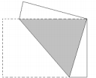

**A) 253 B) 192 C) 189 D) 171 E) NOTA**

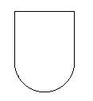

20) The Little Mermaid must have her tongue cut off her the deal with the Witch. A top view of her tongue is provided on the left of this question. Her tongue actually consists of a semicircle directly on top of a rectangle. Given that the diameter of the semicircle is 4 cm and the entire figure is 9 cm, the area of this figure can be left in the form a + b $π$

, where a and b are in square centimeters.What is a + b?

**A) 16 B) 22 C) 30 D) 32 E) NOTA**

21) In exchange for her tongue, the Little Mermaid is given a potion in

a capped vial, as shown on the right. It is in the shape of two cylinders. The height of the entire figure is 11 cm, and the height of the smaller cylinder is 2 cm. The radius of the larger cylinder is 3 and the diameter of the smaller cylinder is 2. What is the surface area of this figure, in square centimeters?

**A) 72 $π$ B) 76 $π$ C) 77 $π$ D) 78**  **E) NOTA**

22) The Little Mermaid comes across an island in the shape of a triangle as shown below.

One side is 6 miles long, one side is 8 miles long, and the angle between the two sides is 60 degrees. The length of the third side can be expressed in the form $a\sqrt{b}$ in simplified form. What is the value of 3b - 17a?

**A) -14 B) -11 C) 2 D) 5 E) NOTA**

23) Let ABCD be a trapezoid with bases AB and CD such that ∠D = 2∠B, AD = 5, and CD = 2. What is the length of AB?

**A) 7 B) 8 C) $\frac{13}{2}$ D) E) NOTA**

24) Circles with centers A and B have radii of 3 and 8, respectively. A common internal tangent intercepts the two circles at points C and D. The lines AB and CD intersect at E. If AE = 5, what is the length of CD?

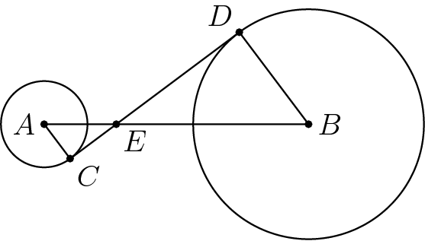

**A)  B) 15 C)  D) 12 E) NOTA**

25) What is the largest number of sides of a regular shape such that identical copies of the shape can tile the xy plane (leaving no space untiled)?

**A) 4 B) 6 C) 8 D) 12 E) NOTA**

26) Two circles with radii of lengths 8 cm and 5 cm are 5 cm apart. Find, in cm, the sum of the lengths of one of their common external tangents and one of their common internal tangents.

**A) $3\sqrt{35}$ + $\sqrt{155}$ B) $3\sqrt{35}$ + $2\sqrt{65}$ C) $3\sqrt{37}$ + $\sqrt{155}$**

**D) + E) NOTA**

27) Circles A, B, and C are all externally tangent to each other, as shown to the left. If AC = 12, BC = 9, and AB = 13, What is the diameter of circle B?

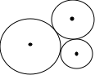

**A) 6 B) 8 C) 10 D) 16 E) NOTA**

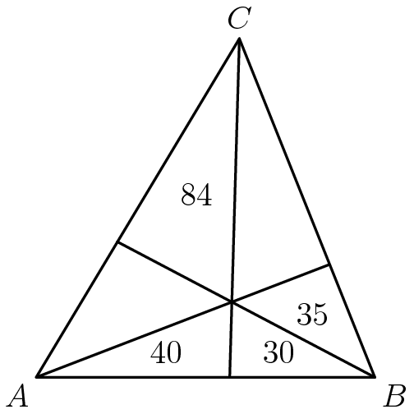28) By drawing lines from the three vertices through a common interior point, triangle ABC is divided into six sections, as shown below. The areas of four of the sections are given. What is the area of triangle ABC?

**A) 284 B) 300 C) 345 D) 315 E) NOTA**

29) Which of these statements are false?

**A) A straight line segment can be drawn joining any two points.**

**B) Given any straight line segment, a circle can be drawn having the segment as radius and one endpoint as center.**

**C) If two lines are drawn which intersect a third line in such a way that the sum of the inner angles on one side is less than two right angles, then the two lines inevitably must intersect each other on that side if extended infinitely.**

**D) If a**[**line segment**](https://en.wikipedia.org/wiki/Line_segment)**intersects two straight**[**lines**](https://en.wikipedia.org/wiki/Line_(mathematics))**forming two interior angles on the same side that sum to less than two**[**right angles**](https://en.wikipedia.org/wiki/Right_angle)**, then the two lines, if extended indefinitely, meet on that side on which the angles sum to less than two right angles.**

**E) NOTA**

30) Quadrilateral ABCD is inscribed in a circle. AB = 10, BC = 9, CD = 12, DA = 5, and AC = 15 (not drawn to scale). What is the length of BD?

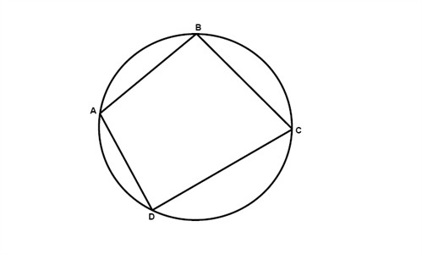

**A) 13 B) 12 C) 11**

**D) 10 E) NOTA**